Data Flow Diagram & User Stories
Project Design Phase-II
Date | 31 January 2025
Team ID | SWTID-2026-1074
Project Name | SB Stocks
Team Size | 5
Team Leader | Venkatesh Illa
Team Members | Durga Meghana Kondempudi, Chandrika Narla, Mogali Shyam, Sravani Jagu
Maximum Marks | 4 Marks

Data Flow Diagrams
A Data Flow Diagram (DFD) shows how data enters and leaves the SB Stocks system, what processes act on it, and where it is stored.
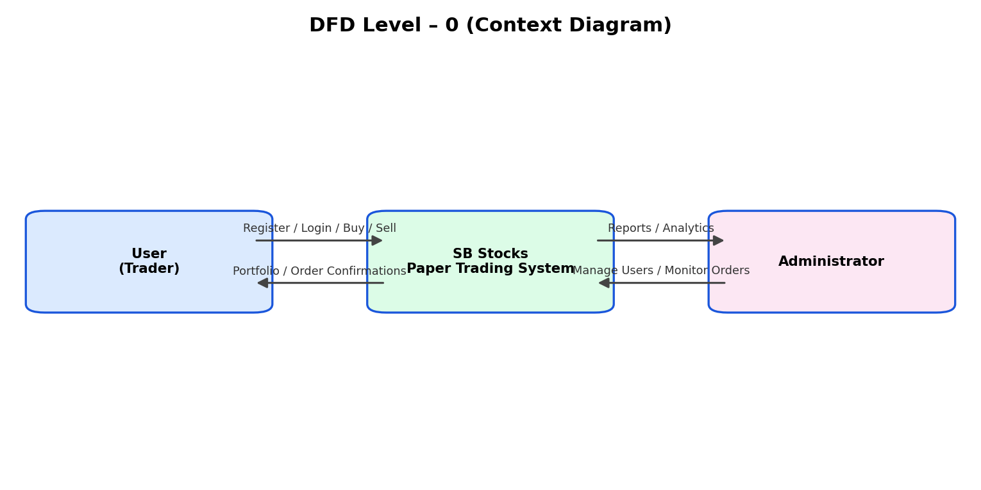
Figure 1: DFD Level-0 (Context Diagram) for SB Stocks
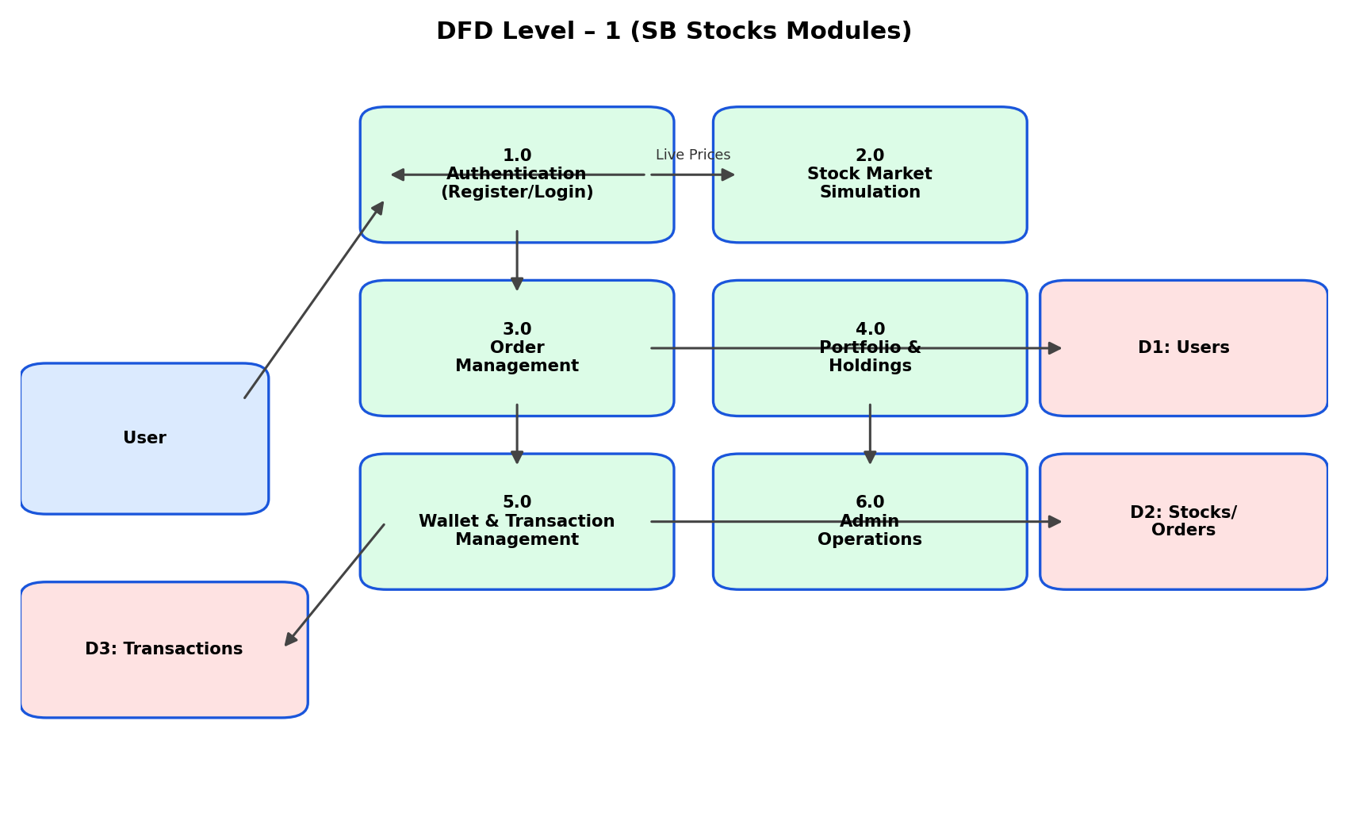
Figure 2: DFD Level-1 — Authentication, Stock Simulation, Order Management, Portfolio, Wallet and Admin modules

User Stories
User Type | Functional Requirement (Epic) | USN | User Story / Task | Acceptance Criteria | Priority | Release
Customer (Mobile/Web Trader) | Registration | USN-1 | As a user, I can register for the application by entering my username, email, user type and password. | I can access my dashboard immediately after successful registration | High | Sprint-1
 |  | USN-2 | As a user, my password is hashed with bcrypt before being stored, so my credentials stay safe. | I can confirm my account was created securely without seeing plain-text passwords anywhere | High | Sprint-1
 |  | USN-3 | As a user, I receive a clear error if I try to register with an email that already exists. | I see 'User already exists' and can log in instead | Low | Sprint-1
 |  | USN-4 | As a user, I can choose my account type (trader/admin) at the time of registration. | My usertype decides whether I land on the trader dashboard or the admin panel | Medium | Sprint-1
 | Login | USN-5 | As a user, I can log into the application by entering my registered email and password. | I receive a JWT token and am redirected to my Home dashboard | High | Sprint-1
 | Dashboard | USN-6 | As a user, I can view trending stocks and my wallet balance on the Home dashboard. | I see live/simulated prices refreshing automatically | High | Sprint-2
Customer (Web user) | Trading | USN-7 | As a user, I can place a Buy order for a stock by selecting quantity and order type (Intraday/Delivery). | My wallet balance reduces and the stock appears in my portfolio | High | Sprint-2
Customer Care Executive | Trading | USN-8 | As a user, I can place a Sell order for stocks I currently hold. | My wallet balance increases and my holdings update instantly | High | Sprint-2
Customer Care Executive | Support | USN-9 | As a support executive, I can view a user's transaction history to resolve wallet disputes. | I can locate the exact deposit/withdraw/buy/sell entry by date | Medium | Sprint-3
Administrator | Admin Panel | USN-10 | As an admin, I can view all registered users, all orders and all transactions across the platform. | I can monitor platform-wide trading activity from one panel | High | Sprint-3
 | Wallet | USN-11 | As a user, I can deposit or withdraw virtual funds through the wallet page. | My balance updates and a transaction record is created with a timestamp | High | Sprint-2
 | Watchlist/History | USN-12 | As a user, I can view my complete order history with prices, quantity and status. | I can review past Buy/Sell decisions to improve my strategy | Medium | Sprint-3

